**Part 1: my video creation**

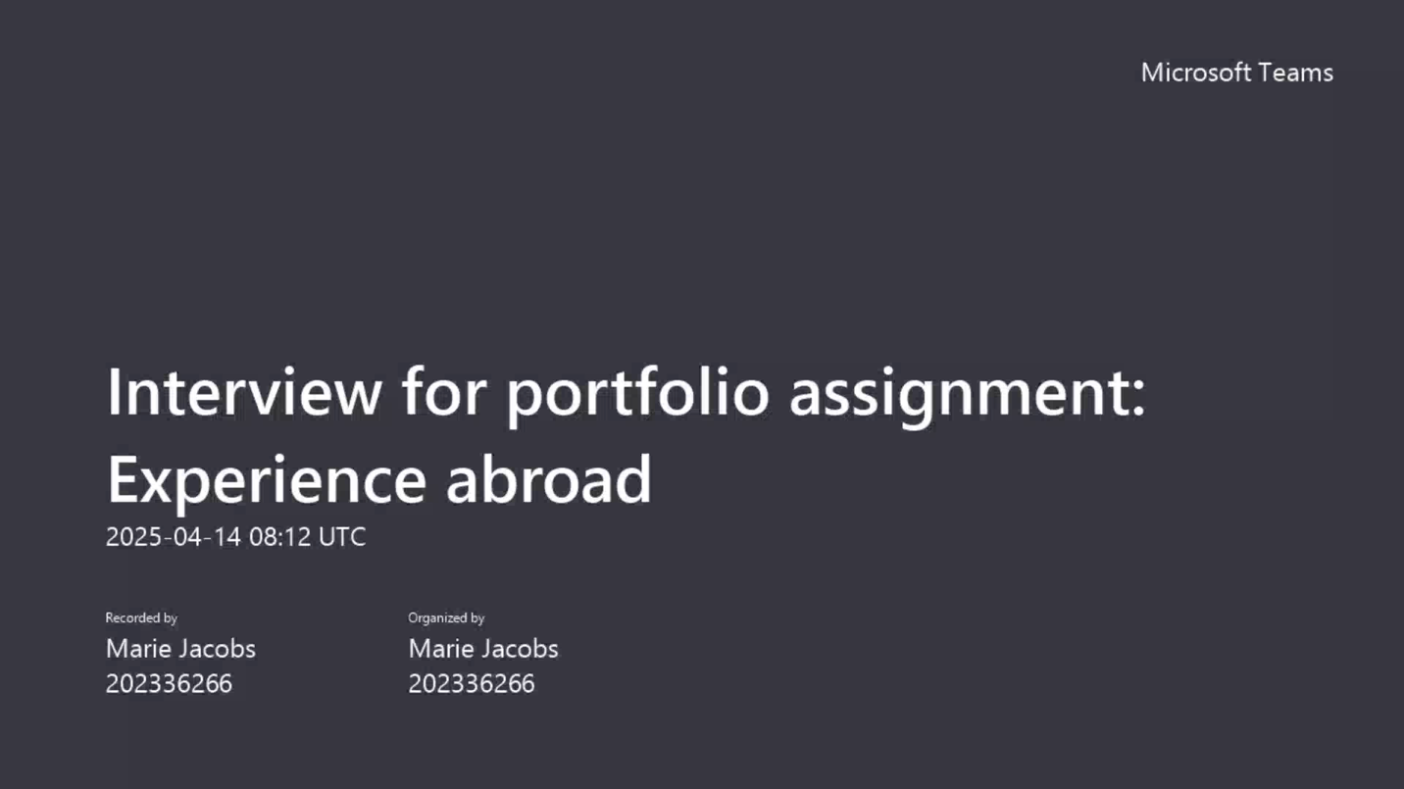

<https://www.icloud.com/attachment/?u=https%3A%2F%2Fcvws.icloud-content.com%2FB%2FAVn2gQ1Bg1xF81MGOtE0vQeC58n5AYJ_smcgv6T2feed0qhVzjL_cNS_%2F%24%7Bf%7D%3Fo%3DAn9J6L_myeNBGtKYWptDIWudGVbctAXCvVDsAtbUG7e7%26v%3D1%26x%3D3%26a%3DCAogu64gCkbUwPy2XsVWiwmZ1xanQCx8ht4BeUDh8usPrO8SehD2s--26jIY9sPqivQyIgEAKgkC6AMA_1zdgjhSBILnyflaBP9w1L9qJ_GDn10n1z3dvPDtEry5jfd8UDRlj4sTuhYS7BbIMKCDfuhQzn-gSXInHsLgeI-thHU39H5BFJYJvAPX59h8WeR_5p6E42q5s_G35k0tlfIl%26e%3D1749148148%26fl%3D%26r%3D7D5FD1FC-368F-40F7-895E-2ECA9E607554-1%26k%3D%24%7Buk%7D%26ckc%3Dcom.apple.largeattachment%26ckz%3D37886252-8423-419F-A20D-79F740CBC9E3%26p%3D68%26s%3DxPQsYo5aqxjh5RNAgWBTB28Go1M&uk=zErqVtNpWiHrgIXsqbAQ_g&f=Interview%20for%20portfolio%20assignment_%20Experience%20abroad-20250414_101226-Opname%20van%20vergadering.mp4&sz=113841131>

**Part 2: critical analysis of 1 video**

Interview Emily Fisher by Jules de Boever

Overall, Emily shows that French culture, or at least in Lyon, is more relaxed and flexible compared to what she is used to in Germany. She noticed this when it comes to work and school. That is the main cultural difference she pointed out. She did not mention many strict rules or strong values, but it is clear that the atmosphere is more laid-back in France. She still felt like the people were open and friendly, especially if you make an effort with the language and culture.

Her attitude towards Lyon is very positive. She liked the city, enjoyed the food, liked walking along the river, and found it easy to make international friends. She did not have much bad to say except that the school campus was not actually in Lyon, but in an area which was not very convenient to get to.

In terms of cultural identity, she still identifies with her German background and mentioned being used to a more structured environment. However, she is also very open to French culture and even chose Lyon specifically to improve her French. She mentioned that locals might be less open if you do not try to learn the language or adapt, which shows that she values respect and cultural exchange.

There was not a deep discussion about cultural identity, but it was clear from the conversation that adapting and being open-minded is important when you study abroad. She didn’t come across as someone who sees cultures in a fixed or stereotypical way. For example, she said that being friendly depends on the individual, which shows she does not make general assumptions about people.

When it comes to the Erasmus student community, she mostly connected with other international students because they were going through the same experience. It was easier to connect with them since they were all far from home and studying the same courses. She did not seem to avoid French students on purpose, but explained that they were busy with internships and less easy to talk to.

Something I would have liked to know more about is how she handled things like speaking French in everyday situations such as shopping or dealing with different situations. I also would have liked more details about housing and how hard it was to find a good place to live.

As a student who is also thinking about going to France, I found this video helpful. It gives a clear and honest look at what life is like in Lyon, what to expect from classes, and how social life works there. The way she explained everything was very casual and easy to relate to.